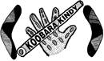
Performance Expression of Interest-Koobara Community Day Event
“Standing Strong, Deadly and Proud in Our Culture for Our Children and Community”

Please complete and return by 20thJanuary 2020

Contact Name:

Address:

Phone:

Email:

Please let us know how you would like to be part of this fantastic event by registering your Act or Talent in the form below:

I would like to take part in the Koobara Community Day Event Open Mic opportunity | Yes No  If yes, what Act or Talent will you be showcasing:
Name of Act/Performance | Name of Act/Performance:
How many people will be performing on stage? | Number of Performers:
Name of people performing. | Names of people performing:
Please be aware that we can only supply the mics and sound system – the artist must bring their own music on USB or CDs. Any other musical equipment must be supplied by the artist/s to plug into the amps supplied. The only exception to this is the drumkit, which will be available for use – however, artist must have own drumsticks.

To be part of the Koobara Community Day Event Open Mic Opportunity, please return the application form by email to administrator@koobara.com.au prior to 4pm on Monday 20th January 2020. If you have any questions, please do not hesitate to contact us on 0407 039 505.

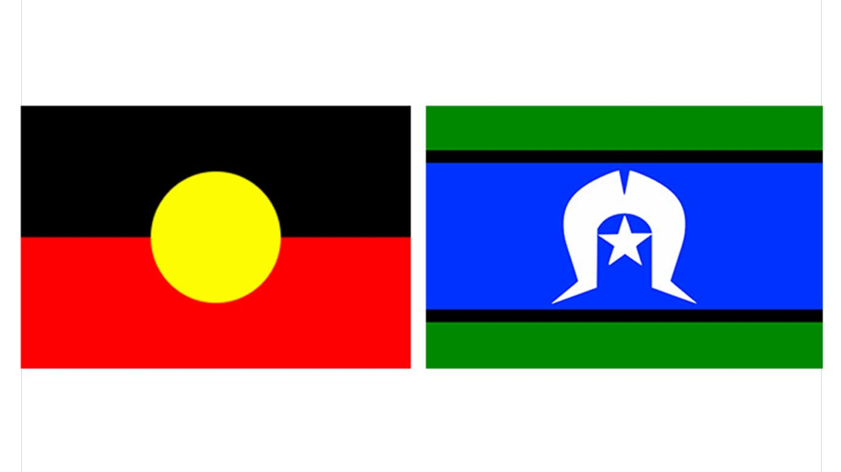
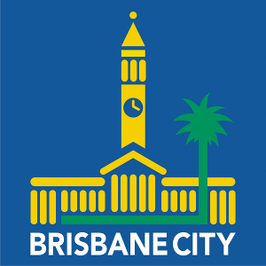
Regards,
Koobara Board

